Bibiana Obler

Taeuber, Sophie (1889–1943)

Artist Sophie Taeuber’s career spanned a variety of movements, including Dada and Constructivism, and media, such as textile arts, interior design, architecture, painting, and sculpture. Although based in Switzerland for most of her life, she was born a German citizen, became Swiss around 1905, and French in 1926. She received a progressive education at Wilhelm von Debschitz's Teaching and Experimental Studios for Applied and Fine Arts, Munich (1910–14), with a break in 1912–13 to study at the School of Applied Arts, Hamburg. From 1916–29 Taeuber was a professor at the Zurich School of Applied Arts, teaching textile design and weaving. Her turned-wood puppets and set designs for the play King Stag (1918), commissioned for the Zurich Marionette Theater, garnered critical acclaim. In addition to establishing a reputation as an innovative applied artist, Taeuber participated in Dada from its inception in 1916, partly as a result of her friendship with Hans Arp, whom she met in 1915, and also through her membership in Rudolf von Laban's dance troupe, which performed at various Dada events. After World War I, Taeuber increasingly turned to interior architecture and fine art, leaving the applied arts almost entirely behind once she moved to Paris in the late 1920s.

Taeuber, although not deemed a founding Dadaist by Dada's founders, was an active participant, contributing her choreography, her signature on the Dada Manifesto of 1918, and one of her turned-wood sculptural heads to the Dada journal Der Zeltweg (1919). During these years, she and Arp collaborated on abstract vertical-horizontal compositions in collage and embroidery; although impossible to date with certainty, these compositions—and Taeuber’s own abstract paintings and textiles—were among the earliest purely abstract works produced by European avant-gardes.

In the 1920s, Taeuber developed an international reputation and worked increasingly as a designer. Her tapestries were featured in exhibitions across Europe and, in 1925, at the International Exhibition of Modern Tapestries, Toledo, USA. She completed various architectural and interior design projects, including a redesign of the Aubette, an entertainment complex in Strasbourg, which she invited Arp and Theo van Doesburg to join her in executing (1926–28). The couple could now afford a house in Clamart, near Paris, which was built and furnished according to Taeuber's plans (1927–28).

In the 1930s, in Paris, Taeuber shifted her energies towards the fine arts, creating carefully balanced compositions of lines and geometric forms in gouache, oil, relief, and collage. She joined the short-lived group Cercle et Carré (1930–31) and then Abstraction-Création, leaving that group in 1934 in disagreement with its dogmatic rejection of all figuration. From 1937–39 Taeuber edited Plastique, a trilingual journal concerned with Concrete Art. She continued to have strong ties with Switzerland, joining the Swiss artists' group Allianz in 1937. She worked closely with her husband on assorted projects, such as the Conjugal Sculpture (1937) and her drawings for his poetry collection Shells and Umbrellas (1938).

Taeuber and Arp escaped Paris before the Germans arrived in 1939, seeking refuge in the south of France. In Grasse, they collaborated with Alberto Magnelli and Sonia Delaunay on a suite of lithographs. They returned to Switzerland in 1942, where Taeuber died in January 1943 of carbon monoxide poisoning from a coal-burning stove.

References and further reading

Aargauer Kunsthaus. Sophie Taeuber-Arp 1889-1943. Aarau, 2010.

Arp-Taeuber, S. H. and Blanche Gauchat. Anleitung zum Unterricht im Zeichnen für textile Berufe. Zurich: Verlag Schul- und Bureaumaterialverwaltung der Stadt Zürich (Gewerbeschule der Stadt Zürich), 1927.

Kuthy, Sandor. Sophie Taeuber—Hans Arp. Künstlerpaare—Künstlerfruende. Kunstmuseum Bern, 1988.

Musée d'art moderne de la ville de Paris and Musée cantonal des beaux-arts de Lausanne. Sophie Taeuber. Paris, Lausanne, 1989.

Obler, Bibiana. Intimate Collaborations: Kandinsky and Münter, Arp and Taeuber. New Haven: Yale University Press, 2014.

Schmidt, Georg, ed. Sophie Taeuber-Arp. Basel: Holbein, 1948.

Taeuber-Arp, Sophie. "Bemerkungen über den Unterricht im ornamentalen Entwerfen." Korrespondenzblatt des Schweiz. Verins der Gewerbe- und Hauswirtschaftslehrerinnen. 14: 11/12 (December 31, 1922): 156-159.

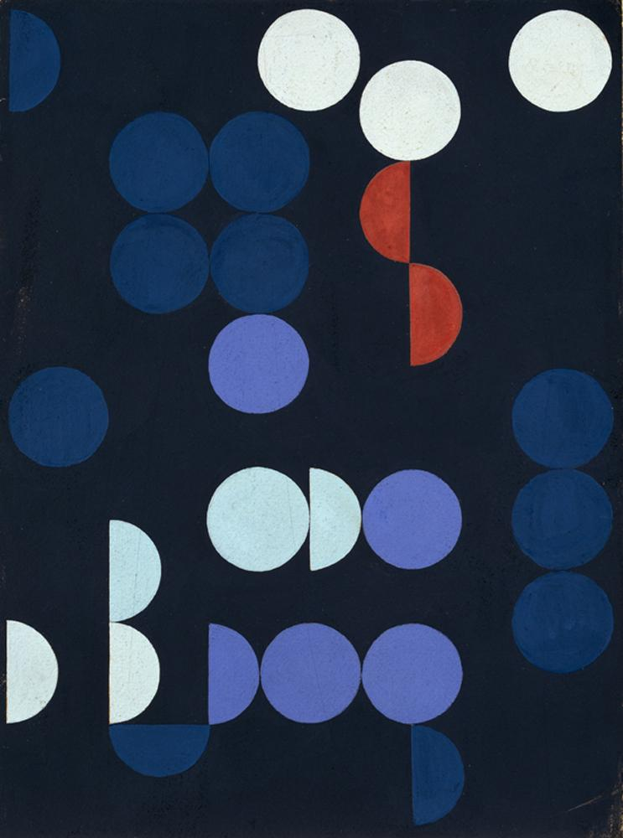

Image: Sophie Taeuber-Arp, Composition of Circles and Semicircles, 1935, gouache on paper. 10 x 13 ½ in. National Museum of Women in the Arts, Washington, DC. Gift of Wallace and Wilhelmina Holladay; © 2012 Artists Rights Society (ARS), New York / VISCOPY, Australia

http://www.nmwa.org/works/composition-circles-and-semicircles

